**Assignment 1**

*Installing VMware's open-source hypervisor and then a Linux distribution using this hypervisor*

I have listed the steps with snapshots to complete the assignment as below:

1. Go to the [VMware open-source hypervisor](https://customerconnect.vmware.com/en/downloads/details?downloadGroup=WKST-PLAYER-1620&productId=1039&rPId=75725) page:

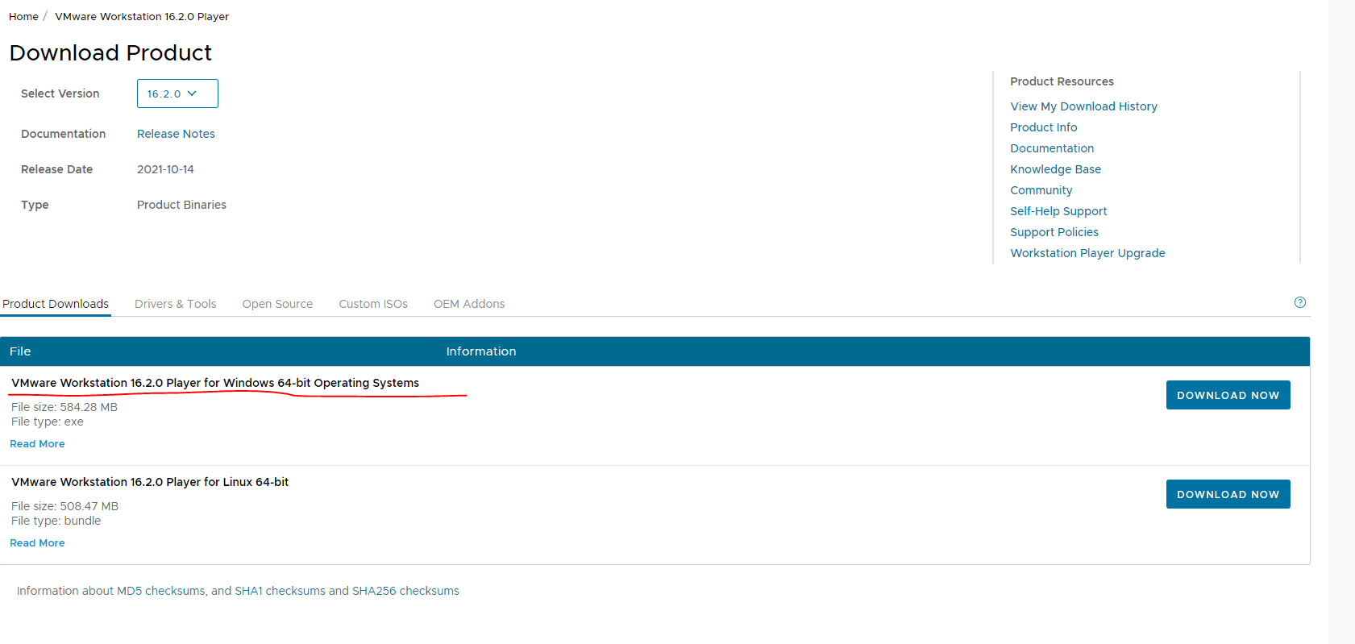

1. Choose the appropriate software (Windows 64-bit for me!) and download the file.
2. After download, run the executable to begin the installation: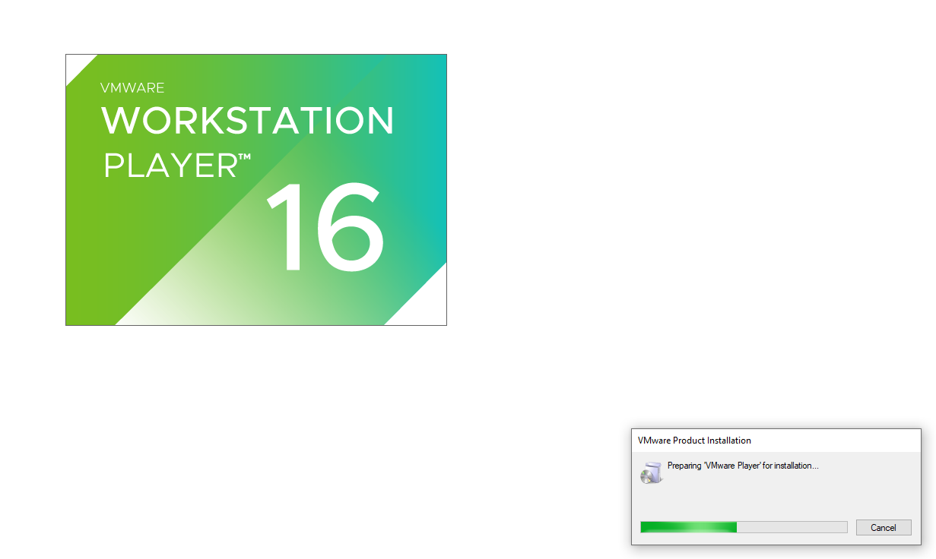
3. You will get the installation prompt. Please click on ‘Next’:

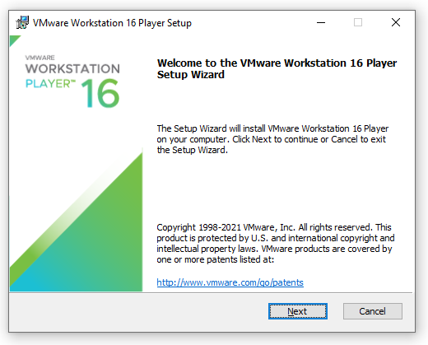

1. Installation of VMware will happen. You will have the view below:

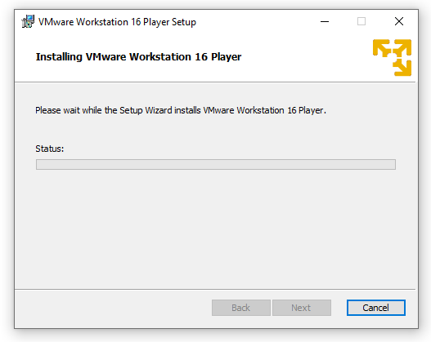

1. On installation and clicking on the Desktop shortcut, you will get the following view. Choose the option for non-commercial use:

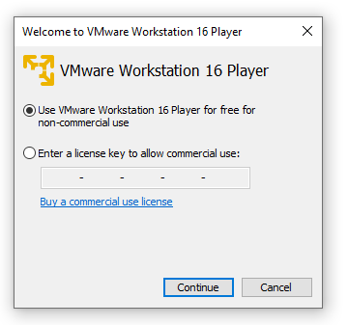

1. When you open the VMware player, you see the following view with option to create a virtual machine:

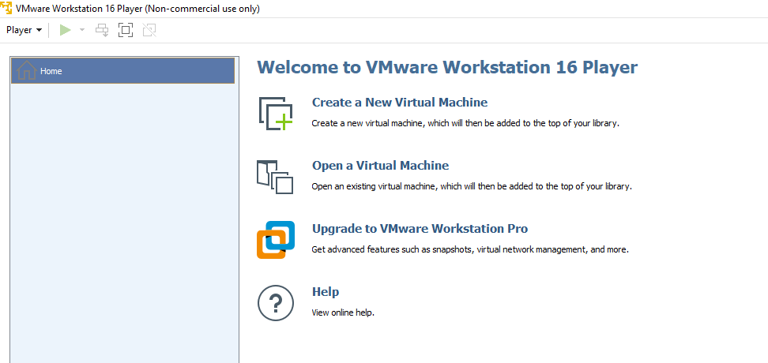

1. Your VMware hypervisor is now ready to host any new virtual machine. We will now move on to installing the Linux (Ubuntu) version on it.
2. Go to the Ubuntu site:

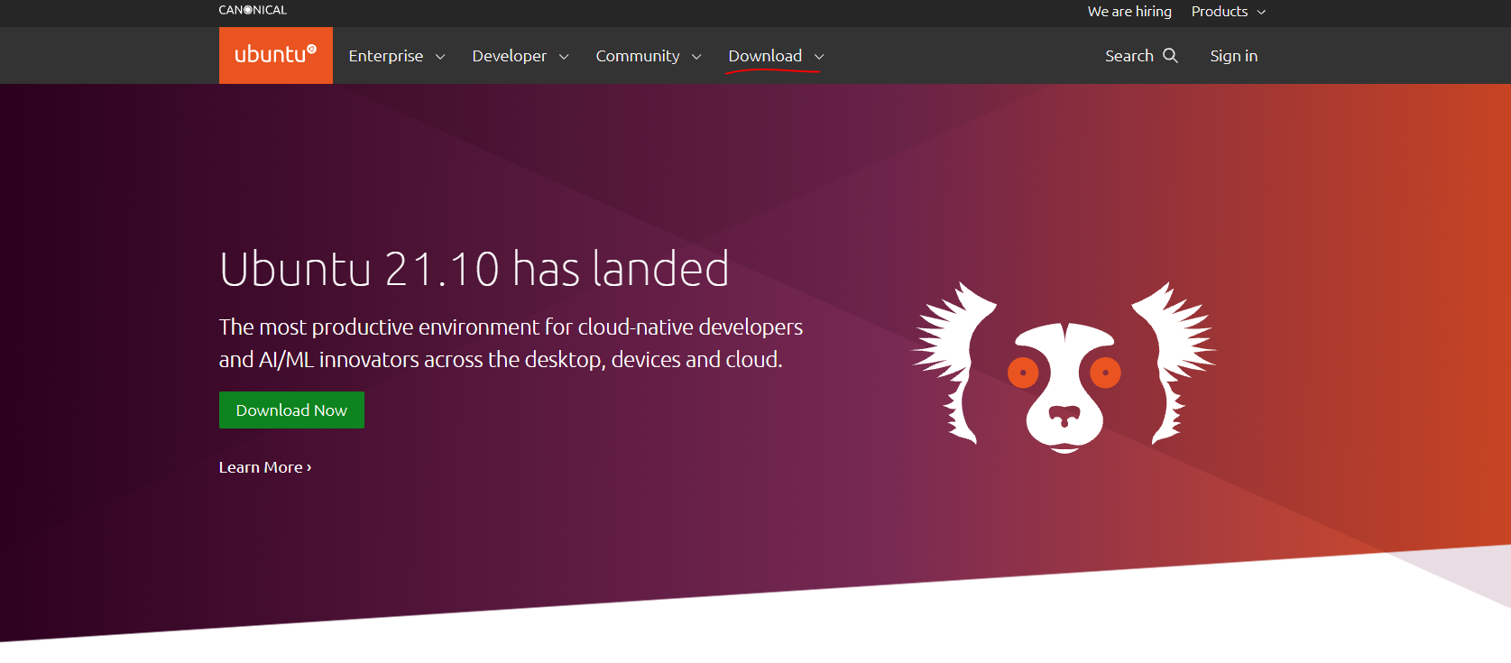

1. Go to the [downloads page](https://ubuntu.com/download/desktop) and download the latest version of the Ubuntu and save it on your computer



1. Next, go to the VMware Player and choose the ‘Create a New Virtual Machine’ option.

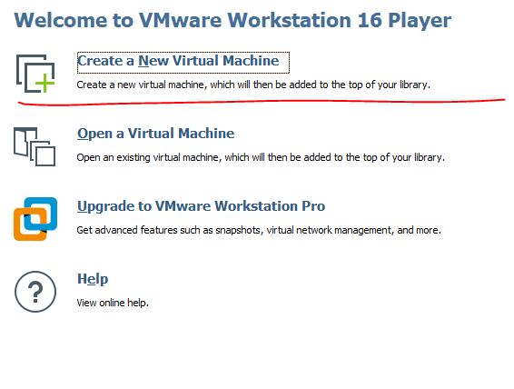

1. A prompt like below – choose I will install Operating System later:

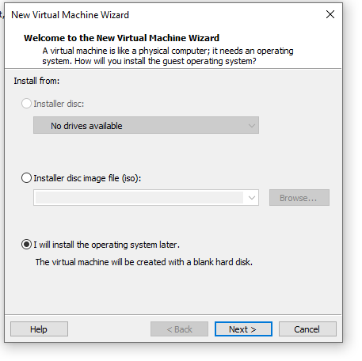

1. Click Next and from the option choose Linux (Ubuntu 64)

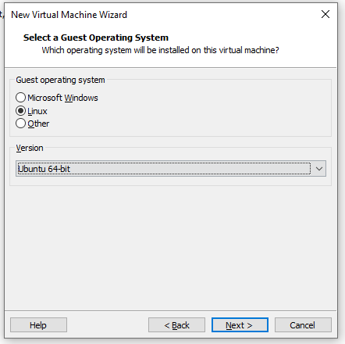

1. Click ‘Next’ and choose the machine name and location

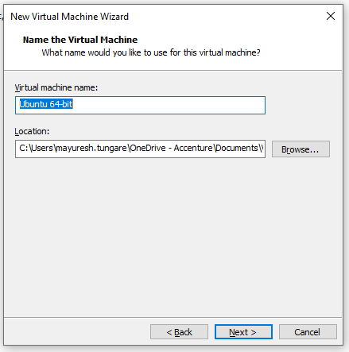

1. Click Next and choose the disk size 20 GB as default and the option to split virtual disk:

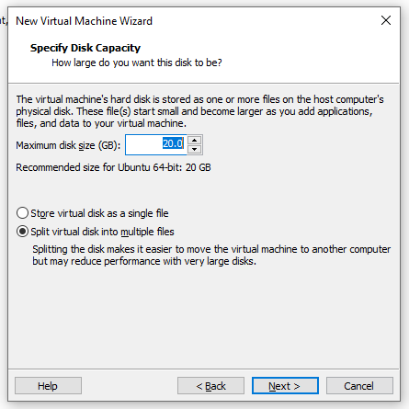

1. Click Next and confirm all the installation details and click on ‘Finish’

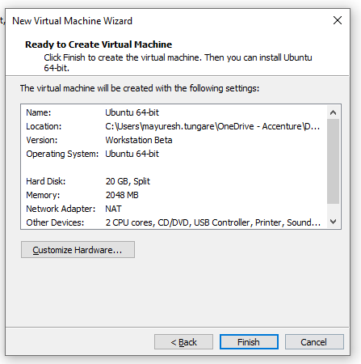

1. You will see the view below:

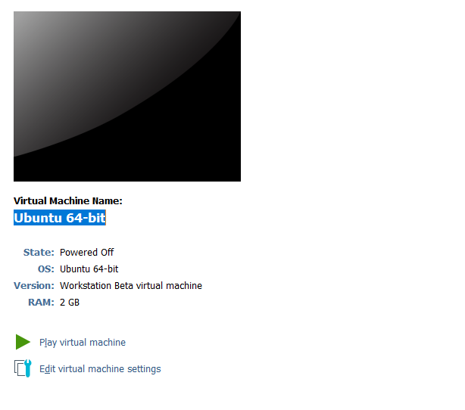

1. Click on Edit virtual machine settings > Hardware options > CD/DVD SATA (Auto detect) and choose the location of your Ubuntu .ISO file on your PC you saved earlier:

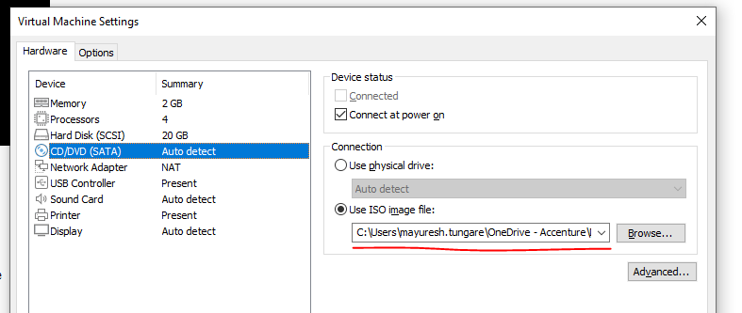

1. After making the required settings, you will see your virtual machine is final ready as below:

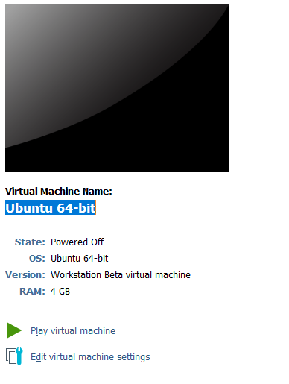

1. Now you click on the Play Virtual machine.
2. After this step, you will need to follow the standard installation process for Ubuntu.

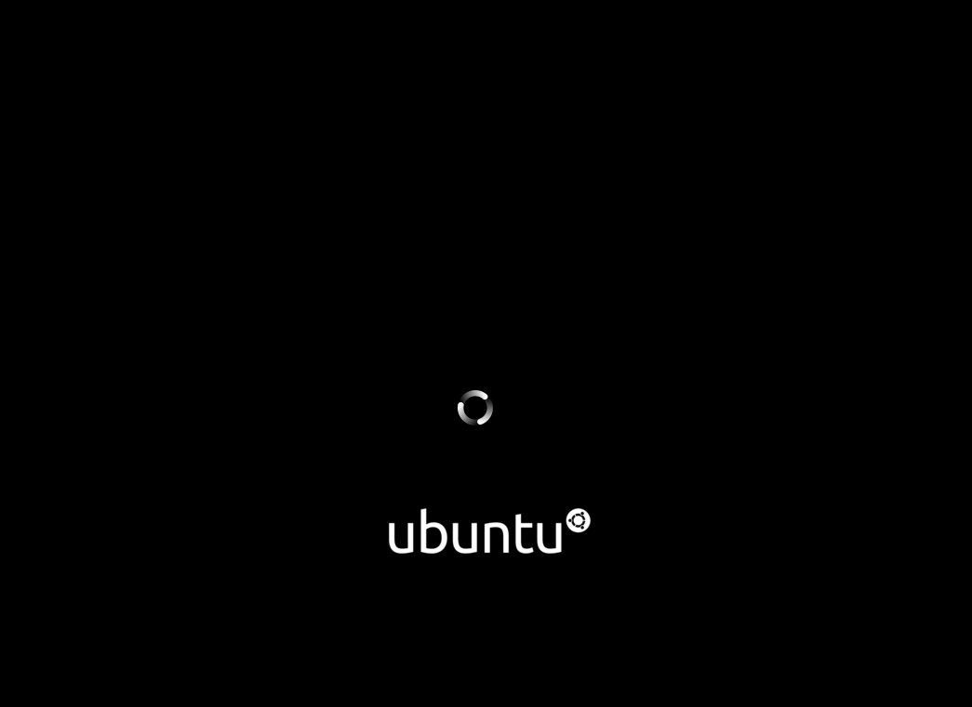

Installation of Ubuntu is now complete.